University of New Hampshire

Magnus Effect on a Cylindrical Airfoil

Project Proposal

Team Members -

Zhangxi Feng, Simon Popecki, James Skinner

ME 646

Professor Todd Gross

Due – 4/13/2017

# Objective

The goal of this experiment is to compare the effects of the rotational speed, diameter, and surface roughness of a rotating thin-wall cylinder on the resulting lift force under the Magnus effect. The lift (Magnus) force is predicted by the Kutta-Joukowski theorem as:

(1)

$$F_{L}=ρυGL$$

Where the lift force on the cylinder, $F$, is linearly related to density of the fluid, $ρ$, velocity of the fluid, $υ$, and the strength of the vortex as a result of the rotation, $G$. The vortex strength is given by:

(2)

$$G={\left(2πr\right)}^{2}s$$

Where $s$ is the rotation of the cylinder in RPS and $r$ is the radius of the cylinder. Substituting vortex strength gives:

(3)

$$F_{L}=ρυL{\left(2πr\right)}^{2}s$$

# Methodologies

## Analytical

From equation (3), we expect a positive linear relationship between the rotation of the cylinder and the lift force and a second order power relationship between the radius and the lift force. We can linearly fit the radius versus lift force data by plotting the square root of the measured lift force versus the radius.

The Solidworks force and stress analysis shows a resulting lift force of 100 N will cause a 6 mm deflection in the solid steel supporting rod. Bending in the rod is undesired since the cylindrical airfoil will be rotating about the rod. Therefore, our maximum airfoil radius would be 10 cm, and we expect to measure a lift force of approximately 50 N at 1000 RPM and an air flow rate of 25 m/s. The plot of lift force versus airfoil radius in shown in figure 1.

On the other hand, it would be beneficial to measure the lift force for a wide range to acquire a better overall view of the relationship. We have set our smallest radius to be 1 cm and equation (3) predicts a lift force of about 0.5 N.

Figure 1: Lift force versus airfoil radius. The force reaches 100 N at a radius of approximately 14 cm, 50 N at 10 cm, and 0.5 N at 1 cm



## Experimental

The force balance is used to measure the lift force felt by the cylinder, which is connected to the force balance via a steel shaft. The AFA2 Single Component Lift and Drag Balance can measure forces up to 0.01 N resolution. The surface roughness is measured by the grit size of the selected sandpapers. The surface roughness could affect the lift force in this case just as the dimples on a golf ball affects the drag force. From the possible relation of the surface roughness and lift force, it is also possible to extrapolate the surface roughness of the cardboard cylinder, which would also serve as a good check for the experimental relationship between surface roughness and lift force since we can do a reality check with the expected surface roughness of the cardboard in comparison with sandpaper. We will also test various rotation speeds at a resolution of 1 RPM. The rotation speed will be controlled by a pulse width modulator using a microcontroller.

## Evaluation

We do not expect the surface roughness to affect the lift force at our scale as much as the cylinder diameter and rotation speed would. At the same time, we will compare the experimental results to predictions of equation (3) to check our results against the most widely accepted theorem. If our lift forces match the predictions then we would be more confident that our surface roughness versus lift force relationship is more precise. Additionally, we will analyze the uncertainty in our measurements to determine the standard deviations and confidence intervals to determine the accuracy of our experimental data.

## Equipment/Test Facilities/Support Needed

We will use cardboard to create our experimental cylindrical airfoils. Then, we will cover the cylinder with three sandpapers of different grit sizes to simulate the rough surfaces. The cylinder will be formed using four wooden annuluses with two closing the cylinder at the ends. The wooden annulus at one end will be connected to the bronze collar that acts as the bearing between the rotating parts and the supporting steel rod. The supporting steel rod will span across the test section of the UNH ME Student Wind Tunnel and attached to the force balance which is used to measure the lift force. The bronze collar is connected to a shaft that will be powered by an electrical motor (MEGA ACn 16/15/8) which transmits power through gears at 2:1 ratio. The apparatus that would be attached to the force balance is shown in figure 2. Assistance may be necessary to properly operate the student wind tunnel.

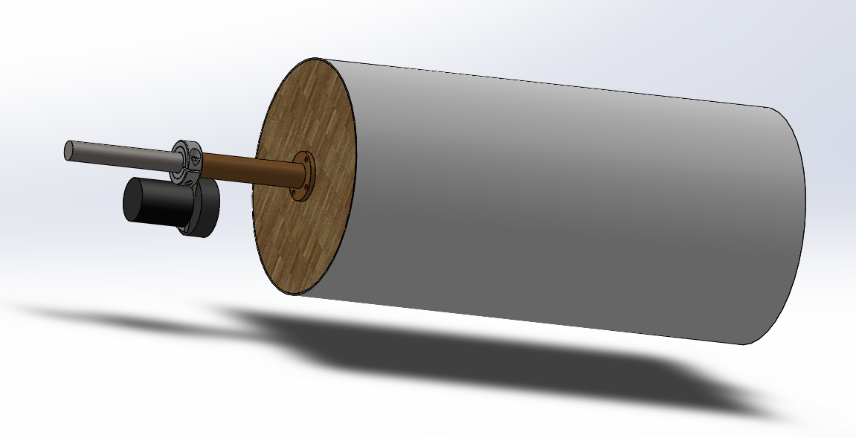

Figure : Motor, bearing, shaft, and cylinder apparatus

# Schedule

# References

1Hall, Nancy, (2015), “Lift of Rotating Cylinder,” NASA Glenn Research Center, last accessed on April 13, 2017, from: https://www.grc.nasa.gov/WWW/K-12/airplane/cyl.html